A1. a:

01000001 00001000 00000000 00000000

0x41080000

b:

11000001110010100000000000000000

0xC1CA0000

c:

2,27

d:

-1.

A2a:

Q = ~~ABC~~ + C + B + A * C

b: 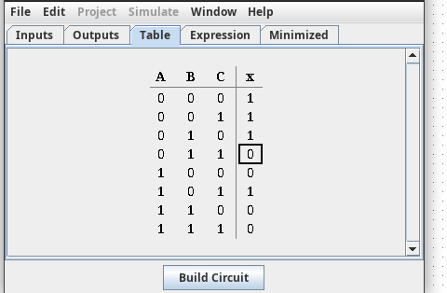

c:

K[Q] = 3 + 1 + 1 + 2 = 7

d:

|  |  |  |  |  |
| --- | --- | --- | --- | --- |
| A/BC | 00 | 01 | 11 | 10 |
| 0 | 1 | 1 | 0 | 1 |
| 1 | 0 | 1 | 0 | 0 |

Q’ = A * C + B * C

e:

K[Q’] = 2 + 2 = 4

F:

Q’ = A * C + B * C

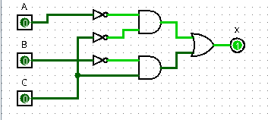  
  
  
  
  
  
  
  
  
  
  
A3A:

Q = D + B * D + A + A * D + A * B + A * B * D

B:

K[Q] = 1 + 2 + 1 + 2 + 2 + 3 = 11

C:

|  |  |  |  |  |
| --- | --- | --- | --- | --- |
| AB/CD | 00 | 01 | 11 | 10 |
| 00 | 0 | 1 | 0 | 0 |
| 01 | 0 | 1 | 0 | 0 |
| 11 | 1 | 1 | 0 | 0 |
| 10 | 1 | 1 | 0 | 0 |

Q’ = D + C + B * D

D:

K[Q’] = 1 + 1 + 2 = 4

E:

Volgens Logisim is de geminimaliseerde vergelijking: C * D + A * C

Deze vergelijking klopt geloof ik.